Kiltearn Kirk Standing Building Survey

Lynne McKeggie
July 2017

Introduction
As part of Evanton Community Trust’s Kiltearn Old Kirk project, professional archaeologist Lynne McKeggie was hired to lead volunteers in learning how to undertake a standing building survey, followed by sessions on site to do a full photograph survey, plan and selected elevation drawings. The present building was a substantial renovation in 1790 or 1790 but incorporates some elements of previous structures.

Methodology
A photographic survey and drawing workshops were undertaken by volunteers and led by Lynne McKeggie in June 2017. The aims of the survey were to:
- record Kiltearn kirk as it currently stands
- identify details which might provide clues as to the phasing of the kirk
- provide training in building recording methods
Two indoor workshops were provided to local volunteers providing training in identifying building types, features, phasing and drawing techniques. Following this 3 sessions were held at the kirk undertaking the photographic survey, ground plan and elevation drawing.
All photographs were taken using a digital SLR camera and a scale was used wherever possible. General elevation shots were taken as well as many detailed shots of surviving features. A photo register was filled in during the survey.
A ground plan was created by setting out base-lines to the south and west of the kirk and measuring the position of the building using tapes. Once the outside dimensions of the building were recorded the interior was measured in. The ground plan was drawn at 1:100 scale.
The eastern elevation of the kirk was drawn at 1:50 scale using a laser distance measurer and using Pythagoras theorem to calculate heights above the baseline.

Results
Photographic survey
The photographic survey has created a detailed record of the current state of the kirk, and provided an opportunity for participants in the project to study all sides of the kirk in detail. This allowed many details to be noticed and recorded, and a summary of the main points have been included below.
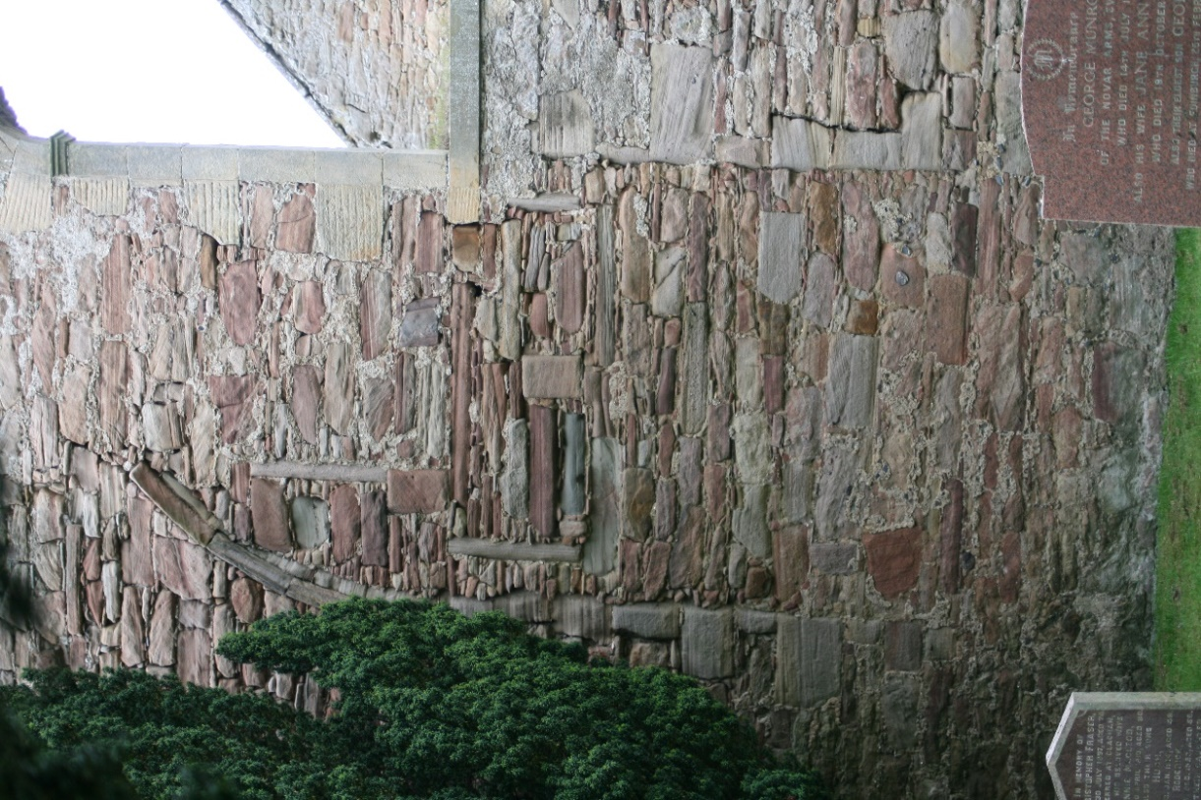
The only apparent surviving part of the medieval kirk is on the east gable and is most apparent on the external façade. Some of the moulding from the arch of the window is clear and is still proud of the wall. This would have been visible even when the church was rendered. The stonework filling in the window is very similar to the stonework to the left and right of it, which may suggest that stone has been reused from other parts of the kirk.
Figure 1: Blocked in medieval window, east gable. (IMG_2482)
There may be several further phases of window within the medieval blocked aperture. In the upper half of the blocking material are some symmetrically placed vertical blocks. It is possible that these were positioned in this way as the window was blocked, but if they are phases of window they would suggest a pair of windows with a central mullion and narrow edging. These have then also been blocked and replaced with a single window set slightly higher up. This in turn has also been blocked, probably at the time of the extensive renovations of 1790, in which the kirk was expanded and the width of the gable increased so that the medieval window is no longer central. The blockwork that fills this window matches that which surrounds the newest window (see Figure 1).
The sides of the medieval window are also visible on the inside of the kirk, however there are also ‘seams’ in the stonework which do not line up with it and no convincing explanation has yet been contrived for these. None of the later phases of window within the medieval aperture are visible from the inside of the kirk.
A single stone decorated with shallow relief carving of foliage may have been reused from the original medieval stonework. This is now located in the upper storey window reveal on the south east side of the main part of the kirk.
A change in stonework is perceptible to the north of the medieval window from inside and outside the kirk. This appears to represent a change from medieval stonework to 18th century. It has been recorded in the ground plan and elevation drawings.
On the outside and inside of the kirk relieving arches are apparent above all the windows and doors. These rough arches are constructed using long narrow stones placed on end and displace the weight from stonework above the window and door lintels (see Figure 2).
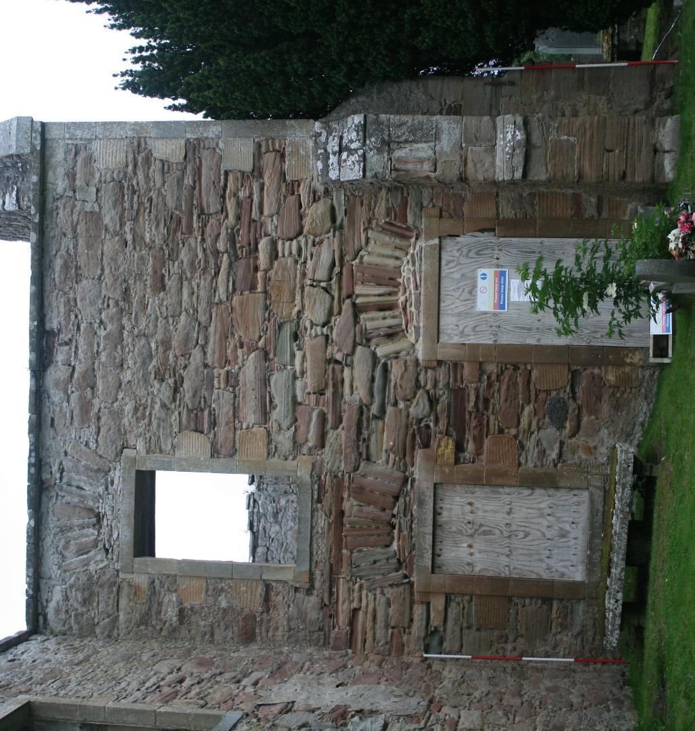
Figure 2: Relieving arches above windows and doors (IMG_2528)
It has been assumed that a large part of the building has been constructed in a single phase during the renovations of 1790. However, there are indications that there are further phases of work.
There is a filled in window on the east wall of the transept. The stones at the edges of the opening are roughly dressed, and the top of the window including the lintel have been interrupted by a later window, so they did not coincide (see Elevation 2). This indicates an earlier phase of building in which the transept was present with less ornamented windows.
There is also some variation in the style of quoins at the corners of the building. The upper parts of all the external corners of the building have finely dressed stones with a slightly raised edge which would have stood proud of the render. However on the lower parts of the east corner of the transept and the south west corner of the main part of the kirk the quoins are more roughly dressed and have no raised edge. This corresponds with the blocked window on the east side of the transept to suggest that there is a phase of the building occurring after the reformation and before the 1790 renovation.
Inside the Kirk the surviving rendering has preserved evidence of where wooden staircases would have been present, giving access to the loft spaces in the east and west wings of the building. Recesses in the stonework where beams would have fitted are also clear in these areas. In some places parts of the wooden beams are still present (see Figure 3).
The Lairds loft in the south transept was accessed from a stone staircase on the outside of the building. Unlike in the east and west wings the beams that would have been present to support this upper floor are not clearly apparent. There is only a single recess underneath each upper story window in the transept which may have supported a beam. There may therefore have been pillars supporting the loft in this area. A previous survey by Hay (conducted before the roof was removed and while the interior was preserved) indicates that this was the case as his plan shows pillars and supporting timber walls below the Lairds loft. Hay’s survey does have some inconsistencies, however, as he shows two windows on the east side of the transept, and a buttress only on the south east corner.
The southern internal wall of the south transept shows the most modern alteration with various areas of brickwork. Two fireplaces have been blocked in what seem to be multiple phases judging by the style of brick. There is also a pipe with infilling brickwork above it to the east of the lower doorway. This is likely to relate to a heating system which replaced the open fireplaces and utilised the chimney of the eastern fireplace.
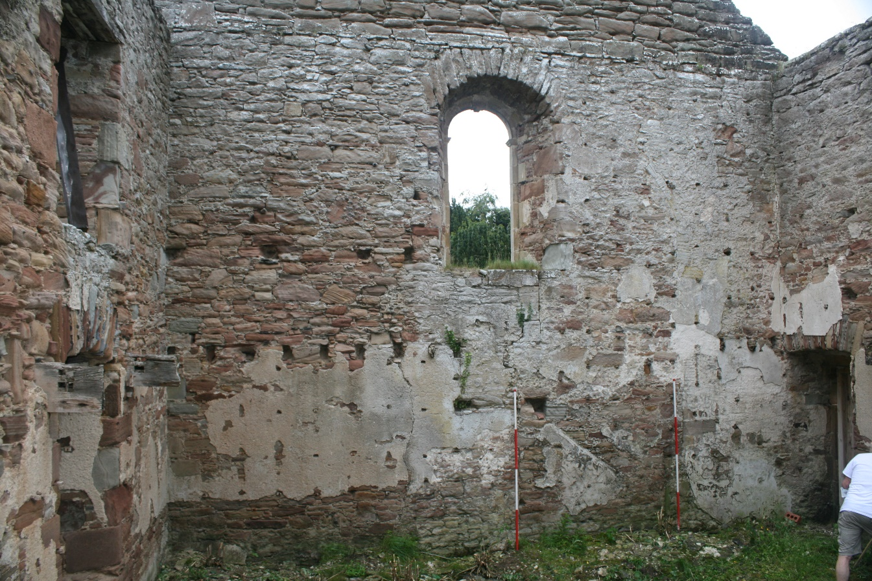
Figure 3: evidence of staircase and supporting beams in east wing (IMG_2560)
Elevation drawings
Two elevation drawings were created, both of the east facing external walls of the Kirk, as these contain various features worthy of recording.
Elevation 1 captures the eastern gable of the main part of the kirk. This is where the only surviving medieval part of the kirk is apparent, evidenced by the arched window moulding that can be seen. There also appear to be several phases of window that post-date the medieval archway but precede the widening of the gable, which is assumed to have taken place in the 18th century.
To the north of the medieval window there is a change in the stonework where the medieval masonry is abutted by the more modern masonry. This has been illustrated in the elevation drawing. However, to the south of the window it becomes much less clear, with no fault line visible.
It is also unclear whether the southern buttress is original or whether it has been rebuilt. It is assumed that the northern buttress has been relocated, as the position of the medieval window suggests that the original gable did not extend that far to the north. The stonework and style of the buttresses is extremely similar.
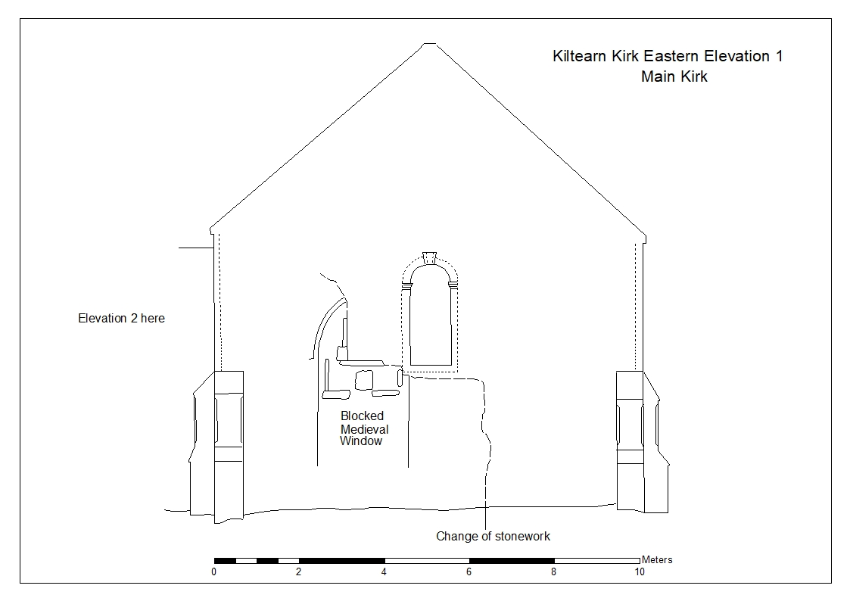
Elevation 2 shows the east facing wall of the transept at the south of the kirk. This elevation shows the relieving arch characteristic of all the window and door openings in the kirk. The open window has edging stones with a straight raised edge, as do the quoins in the upper half of the wall. This is present on all the open windows, doors and the upper quoins across the whole building. However, the sides of the blocked window have plain quoins with no detailing, similar to the corner stones in the lower part of the wall. This suggests an earlier phase of wall with a plain window and quoins that was refurbished with a replacement window set at a higher level and replacing the upper stonework.
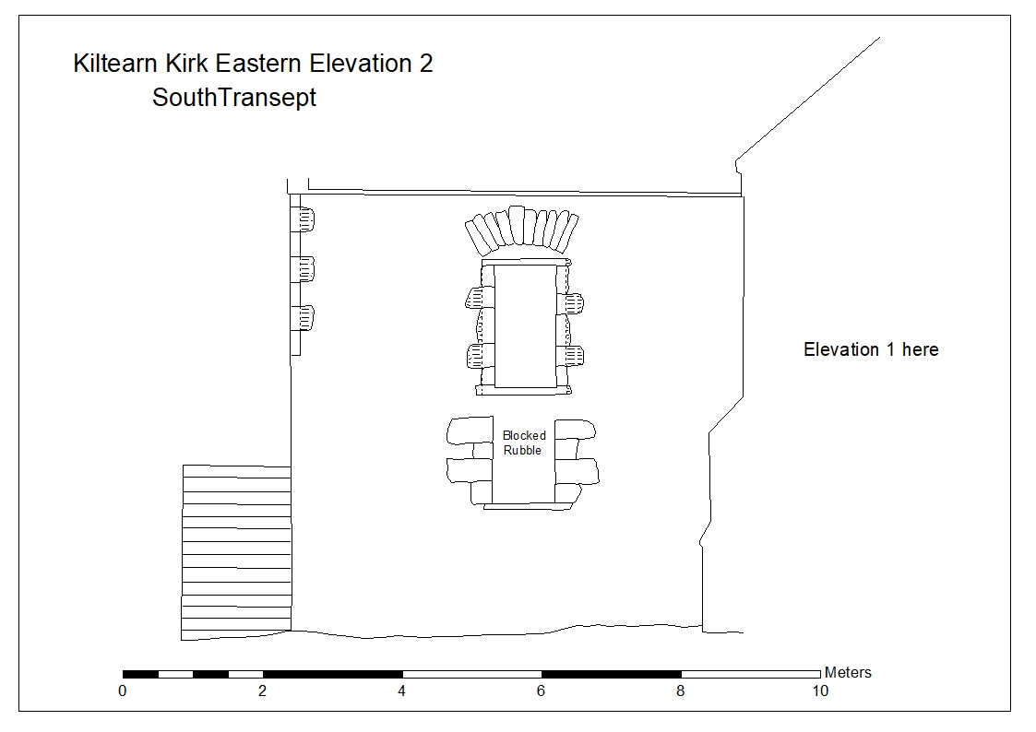
Ground Plan
The ground plan revealed that the building is set slightly off of an east-west orientation erring slightly towards east-north-east to west-south-west. The building is also remarkably symmetrical aside from the discrepancy in the number of windows on each side of the transept and in the presence of buttresses on the east wing of the kirk. These details give clues as to the phasing of the building. Specific dates cannot be attributed to these phases but broader periods can be ascribed.
Phase 1 – This is the earliest phase of the current building and dates to the medieval period. This comprises part of an arched window with elaborate moulding on the east gable. The stonework to each side of this feature consists of stones of varying colour from deep pink to a light sandy colour which are of various sizes but largely long and narrow. Buttresses are also typical of the medieval period and the presence of buttresses on this end of the kirk is likely to relate to the survival of this medieval portion of the building, although they have likely been rebuilt. The position of the window suggests that the building was narrower in this phase. It is also likely to have been a simple rectangle in the style of kirks at the time.
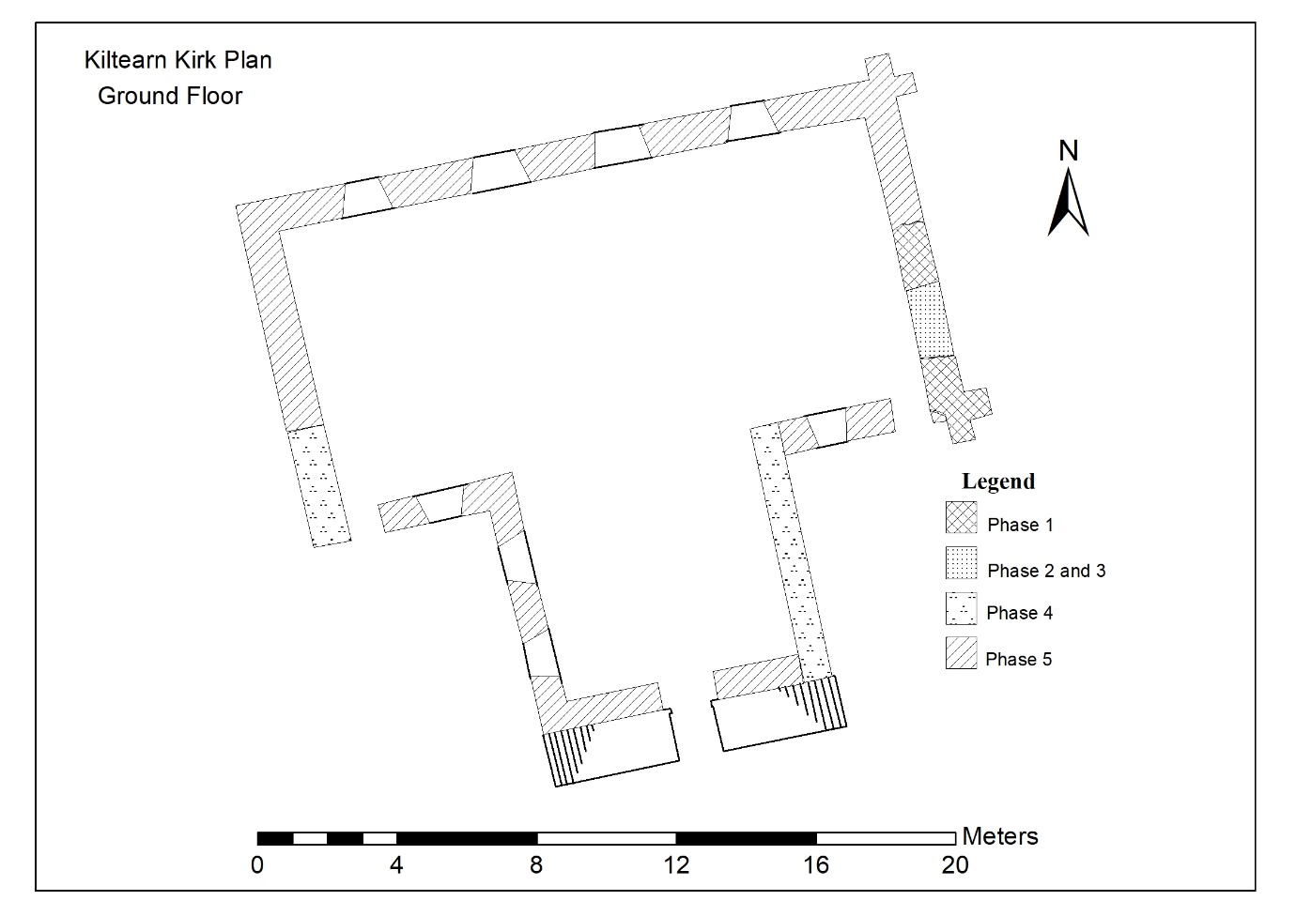
Phase 2 – The medieval arch window is blocked and possibly replaced with a smaller double window with broad central mullion. This is set in the centre of the window and would suggest that the kirk remained the same in width and orientation. The stonework in-filling the medieval window is similar to that which occurs to either side, suggesting that the same stonework is being used and in the same style. It is possible (but not certain) that stonework was reused from elsewhere in the kirk to carry out this infilling phase. The style of the possible double window may hint at a later but pre-reformation date in which a smaller opening was desirable requiring less or no glass but still of an ornamental style befitting the Catholic tradition.
Phase 3 – The double window of phase 2 is replaced with an even smaller and simpler single window. Only two sides of this opening survive so the character is difficult to ascertain, but it is possible that this represents a shift towards the post-reformation simplification of ecclesiastical architecture. The stonework continues to be similar to that in phases 1 and 2. This window remains in the centre of the original medieval opening which suggests that the width of the kirk remained the same as in the previous two phases.
Phase 4 – The kirk appears to have been extended to incorporate a south transept. This style of remodelling into a ‘T’ shape is known to have occurred in religious buildings after the Scottish Reformation of 1560 in order to remove the eastern alter and enable the minister to speak from a pulpit that was more centrally located within the kirk. This phase is characterised by the simple stonework on the lower corners of the west gable and east side of the transept, and of the window on the east of the transept. The stones are large and square with very small stones between, and are mostly pale pink or sandy in colour.
Phase 5 – Extensive remodelling of the kirk takes place in which all of the windows and doors are made in a uniform style, size and position with characterising flat raised edges. The quoins on the upper parts of the whole building also share this, as do the lower quoins on the north-west corner of the main building and the west of the transept. It is also likely that the lairds loft in the south transept was added at this time. The stonework appears indistinguishable from that of phase 4 in every other respect and so the relative extent of this refurbishment is difficult to pinpoint. Therefore the boundaries on the ground plan between phase 4 and 5 do not literally represent changes in stonework, but rather the differences in features outlined above.

Hay, G., 1957 The Architecture of Scottish Post-Reformation Churches 1560-1843, Oxford, Clarendon Press, p.89

